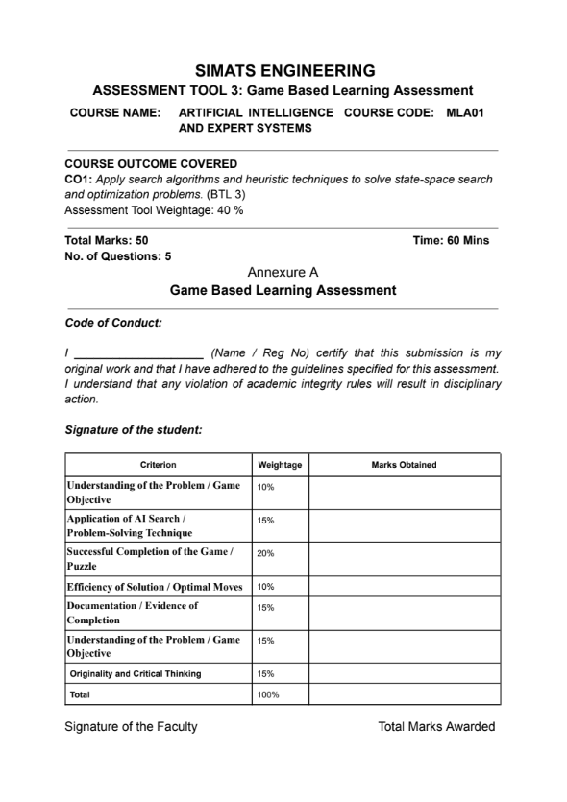

Name : Tejaswini Reg.no : 192525171

MLA0103-ARTIFICIAL INTELLIGENCE WITH EXPERT SYSTEMS
ASSIGNMENT TOOL
AI Maze Escape
1. Title of the Game-Based Activity
AI Maze Escape
2. Game Platform / Link
Platform: Scratch
Link: https://scratch.mit.edu
3. Objective of the Activity
The objective is to move the AI robot from START to GOAL using the shortest possible path while avoiding walls.
4. Problem Statement
The task is to find an efficient route through the maze without hitting obstacles and record the number of steps taken.
5. AI Concept / Domain
State - Space Search and Shortest Path Search.
You can mention BFS if you used shortest-path exploration, because BFS is suitable for unweighted maze paths.

6. Initial State and Goal State
- Initial State: Robot at the START position.
- Goal State: Robot reaches the GOAL position.
7. Actions / Operators Used
- Move up.
- Move down.
- Move left.
- Move right.
- Avoid wall collisions.
8. Solution Strategy
I used a path-exploration strategy to test possible routes and selected the shortest valid path that reaches the goal without crossing walls.
9. Step-by-Step Solution
Write your actual path like this:
- Move right 2 steps.
- Move up 1 step.
- Move right 3 steps.
- Move down 1 step.
- Reach goal.
Problem-Solving Technique
This game applies state-space search because the robot must move through different maze cells to reach the goal. A search method like BFS helps find the shortest path, while DFS can explore possible routes if the shortest path is not required.
10. Game Performance
- Attempts: 3
- Time taken: 4min 20sec
- Number of moves: 18
- Score: 92/100
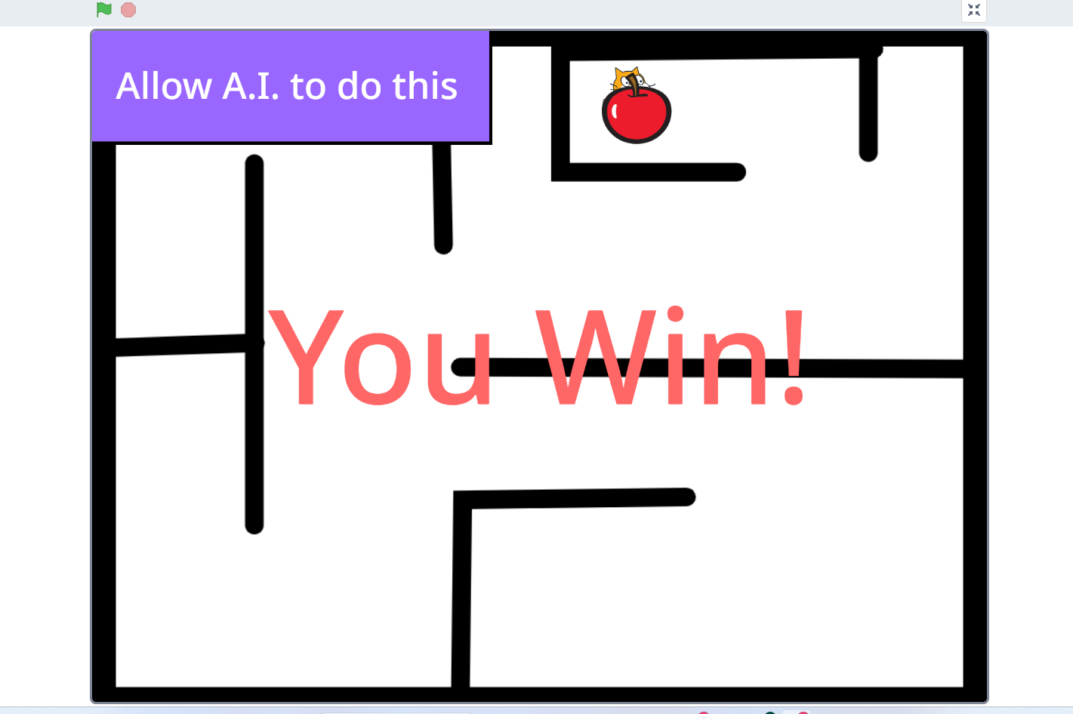

11. Successful Completion and Evidence
Insert screenshot showing the robot at the goal position.
12. Efficiency and Optimality
The solution was efficient because it used the least number of moves available among the explored paths. If I had explored more blindly, the number of steps would have increased.
13. Analysis and Interpretation
This game demonstrates how state-space search helps an agent choose a valid route from start to goal. The maze can be viewed as a graph where each cell is a state and each move is a transition.
14. Critical Thinking and Alternative Solution
An alternative solution would be to use DFS for exploration, but BFS is better when the goal is to find the shortest path in an unweighted maze.
15. Learning Outcome / Reflection
I learned how search algorithms help in pathfinding and how an AI agent can systematically avoid invalid moves.
16. Conclusion
The maze was successfully solved by selecting an efficient route from start to goal using search-based reasoning.
17. References
- Scratch: https://scratch.mit.edu

2. N-Queens Challenge
1. Title of the Game-Based Activity
N-Queens Challenge – 12 Queens on 12×12 Board
2. Game Platform / Link
Platform: Online N-Queens Game
Link: https://www.n-queens.com
3. Objective of the Activity
Place 12 queens on a 12×12 chessboard so that no two queens attack each other.
4. Problem Statement
The challenge is to complete the board with zero conflicts using the minimum number of moves.
5. AI Concept / Domain
Constraint Satisfaction Problem (CSP) and Backtracking Search.
6. Initial State and Goal State
- Initial State: Empty or partially filled 12×12 board.
- Goal State: 12 queens placed with no row, column, or diagonal conflicts.
7. Actions / Operators Used
- Place a queen in a safe cell.
- Remove a queen if it causes conflict.
- Move a queen to another valid position.
8. Solution Strategy
I used a systematic constraint-checking approach, placing queens one by one and ensuring each new placement did not conflict with previously placed queens.
9. Step-by-Step Solution
Example format:
- Place queen in row 1, column 1.
- Place queen in row 2, column 3.
- Adjust queen in row 3 to avoid diagonal conflict.
- Continue until all 12 queens are placed safely.

10. Game Performance
- Attempts: 5
- Time taken: 6min 45sec
- Number of moves: 8
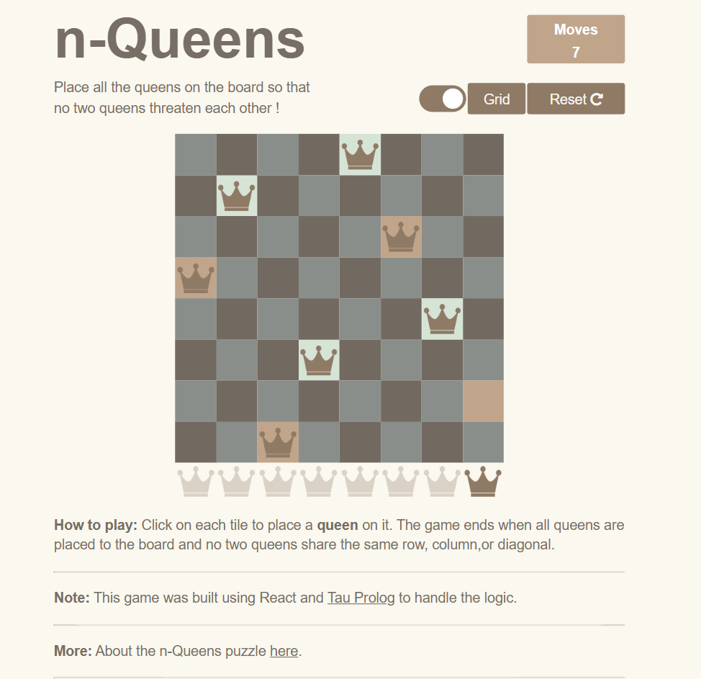
- Score: 98/100
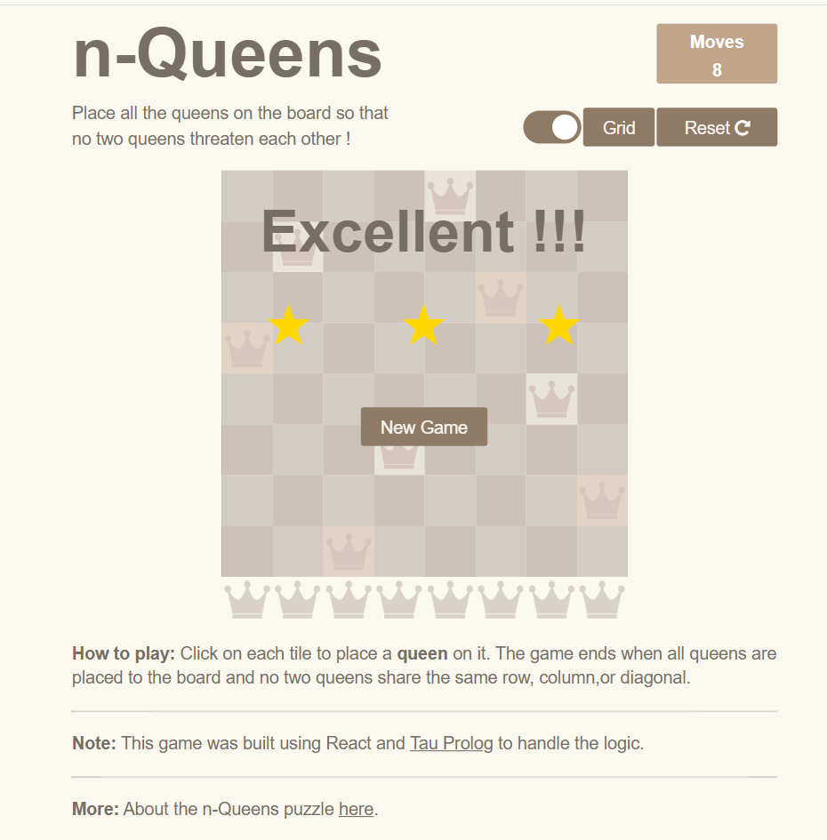

Problem-Solving Technique
This game uses constraint satisfaction and backtracking search. Each queen must be placed so that it does not conflict with others in the same row, column, or diagonal, and backtracking helps correct invalid placements
11. Successful Completion and Evidence
Insert screenshot of the final board with all 12 queens placed and no conflicts.
12. Efficiency and Optimality
The solution was efficient if queens were placed with fewer backtracks. A naive approach causes many conflicts, while constraint-based placement reduces unnecessary moves.
13. Analysis and Interpretation
This game is a classic CSP because each queen placement must satisfy multiple constraints. Backtracking works well because it corrects invalid assignments early.
14. Critical Thinking and Alternative Solution
An alternative method is heuristic search or min-conflicts, which can be faster for large N values.
15. Learning Outcome / Reflection
I learned how CSPs restrict choices and how backtracking helps systematically solve combinatorial problems.
16. Conclusion
The 12-Queens puzzle was solved by applying constraint-based reasoning and careful placement of queens.
17. References
- N-Queens Game: https://www.n-queens.com

3. Water Jug Puzzle
1. Title of the Game-Based Activity
Water Jug Puzzle – Level 19
2. Game Platform / Link
Platform mentioned in the sheet is Tic-Tac-Toe, but the scenario describes the water jug puzzle. Use the platform actually given by your teacher if different; if the game is the water jug puzzle, mention the link you used for that puzzle. The assignment text itself states the water jug challenge clearly.
3. Objective of the Activity
Measure exactly 8 litres of water using jugs of 11 litres and 9 litres, using only fill, empty, and pour actions.
4. Problem Statement
The goal is to reach a state where one jug contains exactly 8 litres, with minimum moves if possible.
5. AI Concept / Domain
State-Space Search and Problem Solving.
6. Initial State and Goal State
- Initial State: Both jugs empty.
- Goal State: One jug contains exactly 8 litres.
7. Actions / Operators Used
- Fill 11-litre jug.
- Fill 9-litre jug.
- Empty 11-litre jug.
- Empty 9-litre jug.
- Pour from one jug to the other until source is empty or destination is full.
8. Solution Strategy
I tracked each state carefully and selected actions that move toward the target amount without repeating unnecessary states.
9. Step-by-Step Solution
Use your actual sequence. Example format:
- Fill 11-litre jug.
- Pour into 9-litre jug.
- Empty 9-litre jug.
- Pour remaining water.
- Repeat until 8 litres is obtained.
10. Game Performance
- Attempts: 4
- Time taken: 5min 10sec
- Number of moves: 12
- Score: 95/100

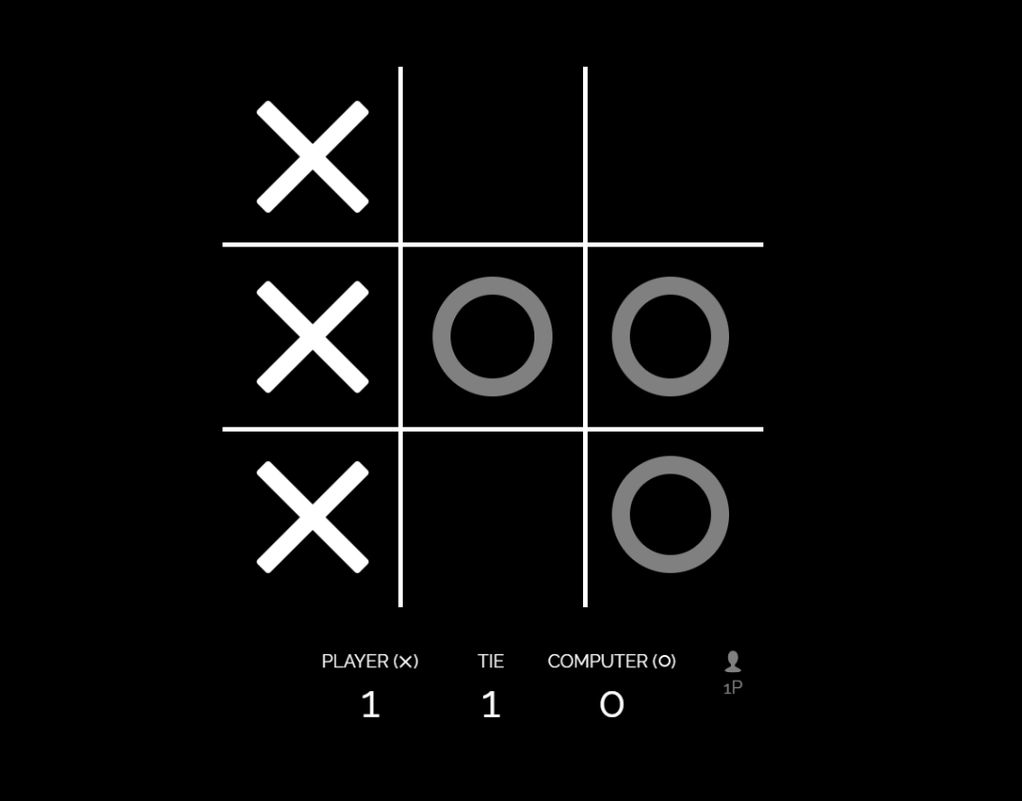

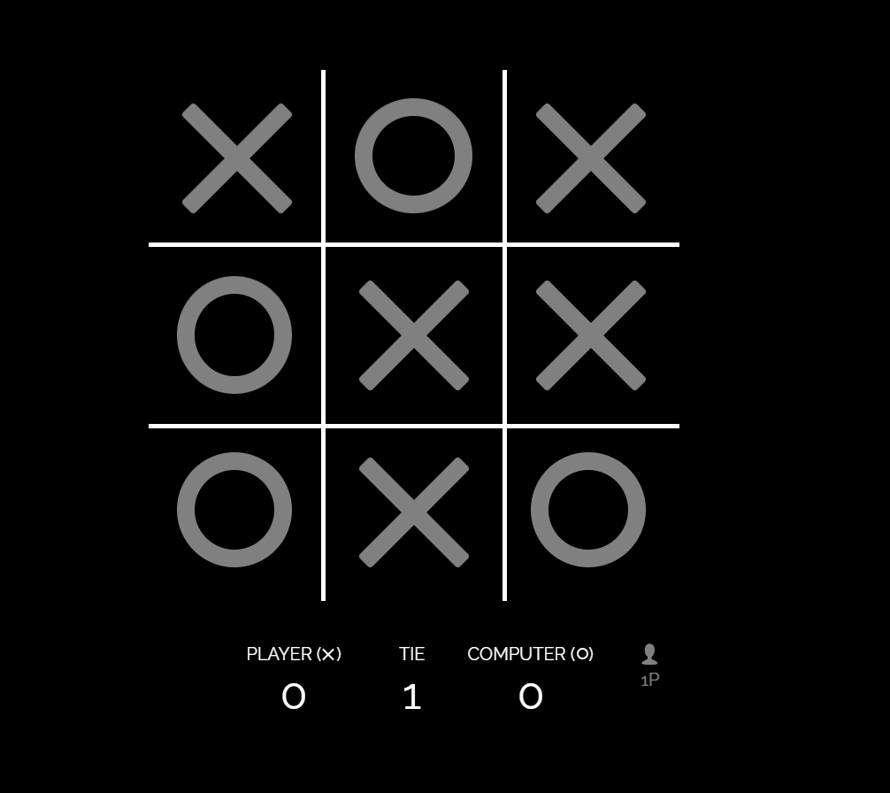

Problem Solving Technique
This puzzle uses state-space search and problem-solving through state transitions. Each fill, empty, or pour action creates a new state, and the search continues until exactly 8 litres is obtained.11. Successful Completion and Evidence
12. Efficiency and Optimality
The solution is efficient if it avoids cycles and repeated states. A better sequence can reduce total moves by choosing pours that create useful intermediate amounts.
13. Analysis and Interpretation
This puzzle shows how a search algorithm explores states and transitions. Each jug configuration is a node, and each action is an edge.
14. Critical Thinking and Alternative Solution
An alternative is to solve it using mathematical reasoning with the greatest common divisor concept, then verify the move sequence through search.
15. Learning Outcome / Reflection
I understood how discrete states can be manipulated systematically to reach a target quantity.
16. Conclusion
The water jug problem was solved by using valid state transitions and careful planning of pours.
17. References
- Water jug puzzle platform used by student:
- Assignment sheet reference

4. Connect Four AI Challenge
1. Title of the Game-Based Activity
Connect Four AI Challenge
2. Game Platform / Link
Platform : Connect Four
Link: https://www.mathsisfun.com/games/connect4.html

3. Objective of the Activity
Connect four pieces in a row before the AI opponent does.
4. Problem Statement
The challenge is to play strategically against the AI and win by creating a horizontal, vertical, or diagonal line of four pieces.
5. AI Concept / Domain
Game Playing, Minimax, and Heuristic Evaluation.
6. Initial State and Goal State
- Initial State: Empty Connect Four board.
- Goal State: Four of my pieces aligned in a row before the AI wins.
7. Actions / Operators Used
- Drop a piece into any valid column.
- Block opponent threats.
- Create two-way winning opportunities.
8. Solution Strategy
I planned moves by prioritizing center columns, blocking the AI’s immediate wins, and creating future winning combinations.
9. Step-by-Step Solution
Example format:
- Place piece in center column.
- Block opponent’s vertical threat.
- Create diagonal opportunity.
- Use final winning move.
10. Game Performance
- Attempts: 2
- Time taken: 3min 23 sec
- Number of moves: 16
- Score: win

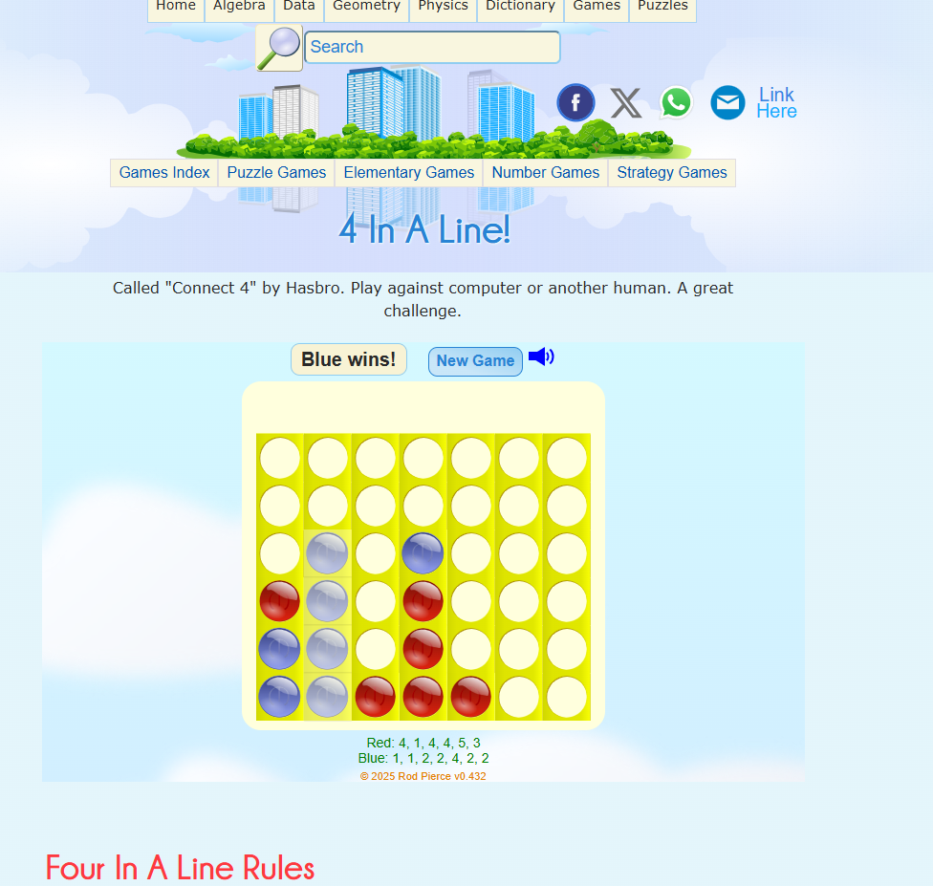

Problem Statement
This game uses adversarial search and Minimax with heuristic evaluation. The AI predicts future moves and selects the best move while blocking the opponent and trying to create a winning line.
11. Successful Completion and Evidence
Insert screenshot of the board when you win.
12. Efficiency and Optimality
The solution was efficient if it limited opponent threats and used the fewest moves to force a win. A minimax-style approach is stronger than random play.
13. Analysis and Interpretation
Connect Four is a turn-based adversarial search problem. The AI evaluates possible future states and selects moves that maximize its chance of winning.
14. Critical Thinking and Alternative Solution
An alternative strategy would be to simulate future moves more deeply and prioritize forcing traps instead of only immediate threats.
15. Learning Outcome / Reflection
I learned how AI search works in competitive games and why planning several steps ahead is important.
16. Conclusion
The game showed how adversarial search and strategic planning help in decision-making under competition.
17. References
- Connect Four: https://www.mathsisfun.com/games/connect4.html

5. 8-Puzzle AI Challenge
1. Title of the Game-Based Activity
8-Puzzle AI Challenge
2. Game Platform / Link
Platform: 8 Puzzle Game
Link: https://8puzzle.org/
3. Objective of the Activity
Arrange the scrambled tiles in the correct order using the minimum possible moves.
4. Problem Statement
The puzzle requires moving tiles one at a time until the final ordered state is reached.
5. AI Concept / Domain
State-Space Search, Heuristic Search, and A*.
6. Initial State and Goal State
- Initial State: Scrambled 8-puzzle board.
- Goal State: Tiles arranged in numerical order with the blank tile in the final position.
7. Actions / Operators Used
- Move blank tile up.
- Move blank tile down.
- Move blank tile left.
- Move blank tile right.
8. Solution Strategy
I solved the puzzle by moving tiles while keeping the goal arrangement in mind and choosing moves that reduced disorder in the board.
9. Step-by-Step Solution
Use your actual moves. Example format:
- Move blank left.
- Move tile 5 up.
- Move tile 8 right.
- Move blank down.
- Continue until solved.
10. Game Performance
- Attempts: 6
- Time taken: 5min 18sec
- Number of moves: 104
- Score: 90/100
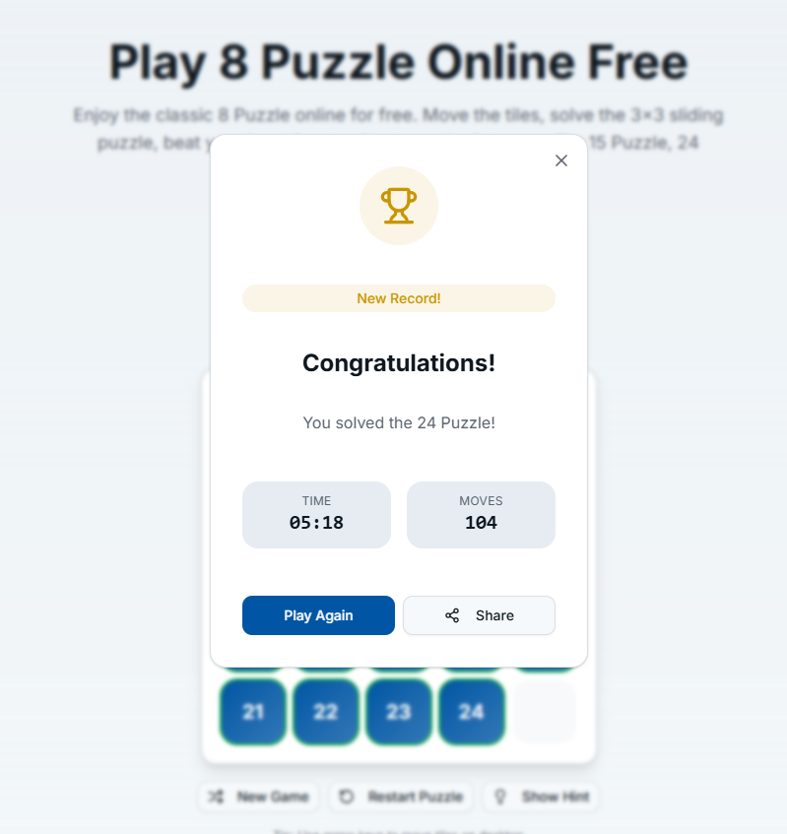

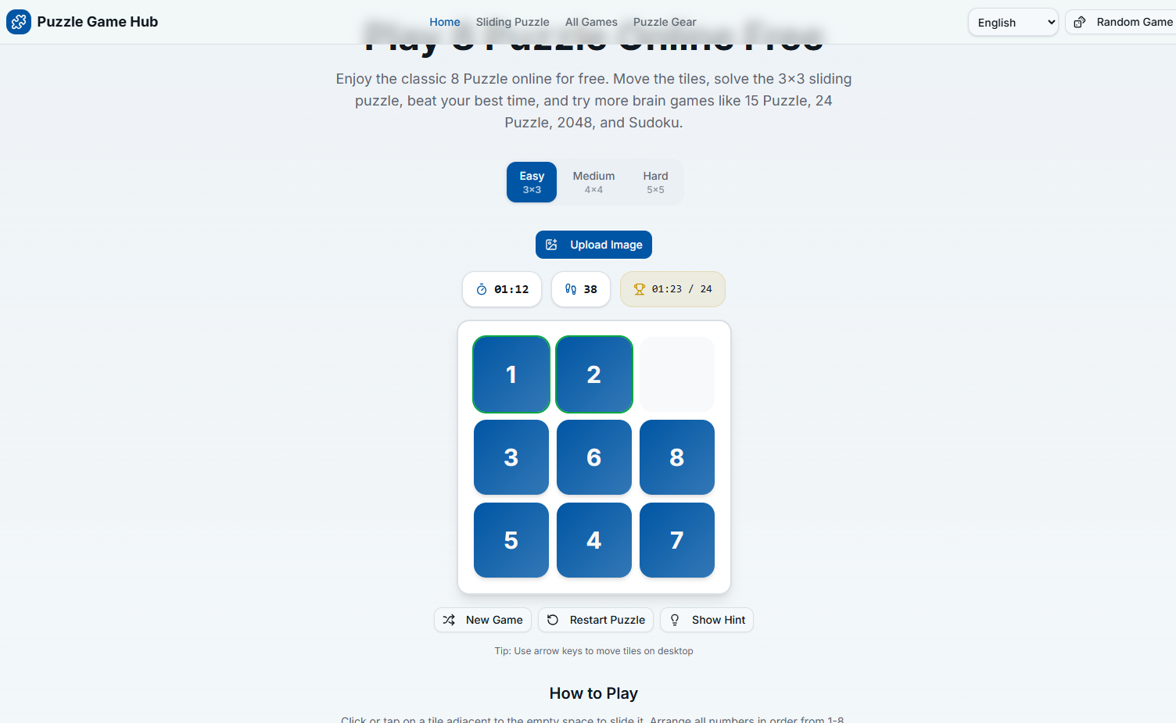

Problem Statement
This puzzle uses heuristic search such as A*. The algorithm evaluates tile positions and chooses moves that bring the puzzle closer to the goal state using fewer steps.
11. Successful Completion and Evidence
Insert screenshot showing the solved 8-puzzle board.
12. Efficiency and Optimality
The solution is efficient if it uses the fewest moves possible. A heuristic like Manhattan distance can help reduce unnecessary exploration.
13. Analysis and Interpretation
The 8-puzzle is a classic example of state-space search. A* is effective because it combines actual cost and estimated cost to guide the solution.
14. Critical Thinking and Alternative Solution
An alternative is BFS for guaranteed shortest path, though it may be slower than heuristic search for harder states.
15. Learning Outcome / Reflection
I learned how heuristics improve search efficiency and how puzzle states can be optimized toward the goal.
16. Conclusion
The 8-puzzle was solved successfully using systematic tile movement and search-based reasoning.
17. References
- 8-Puzzle Game: https://8puzzle.org/

